Project Design Phase-II
Solution Requirements (Functional & Non-functional)

Date | 31 January 2025
Team ID | SWTID-2026-5360
Project Name | Heart Disease Analysis
Maximum Marks | 4 Marks

Functional Requirements:
Following are the functional requirements of the proposed solution.
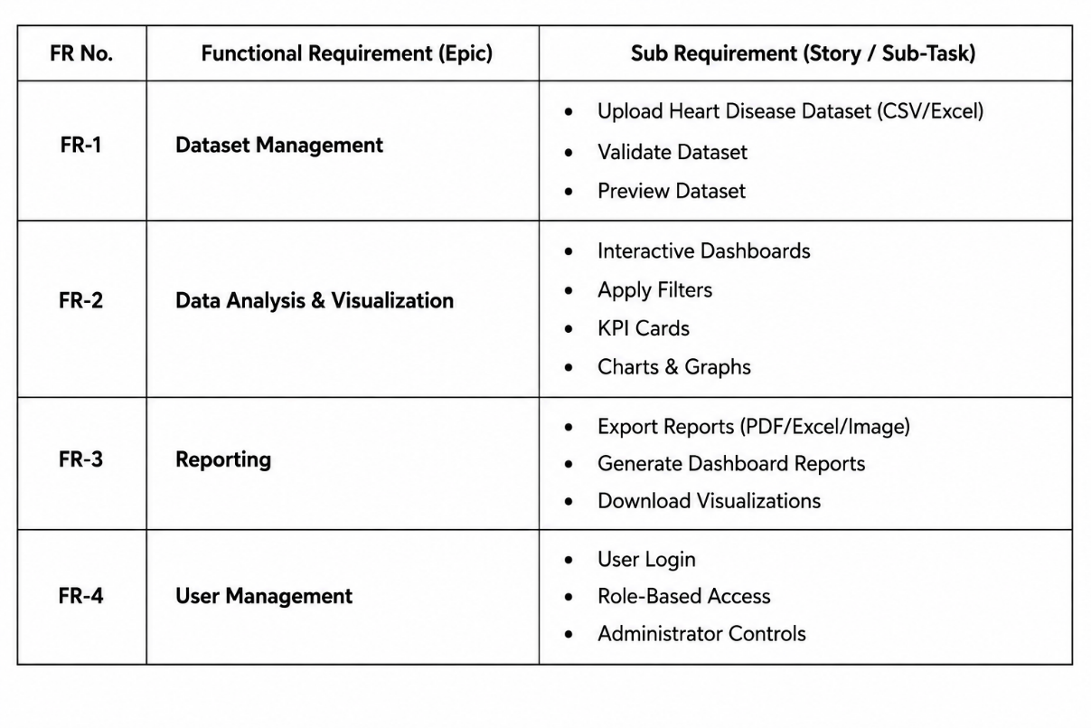
Non-functional Requirements:
Following are the non-functional requirements of the proposed solution.
